background-attachment en CSS

Adjunto de fondo CSS
La propiedad background-attachment especifica si la imagen de fondo debe desplazarse o ser fija (no se desplazará con el resto de la página):

Ejemplo
Especifique que la imagen de fondo debe arreglarse:
body {
background-image: url("img_tree.png");
background-repeat: no-repeat;
background-position: right top;
background-attachment: fixed;
}

Ejemplo completo:
<!DOCTYPE html>
<html>
<head>
<style>
body {
background-image: url("img_tree.png");
background-repeat: no-repeat;
background-position: right top;
margin-right: 200px;
background-attachment: fixed;
}
</style>
</head>
<body>

<h1>The background-attachment Property</h1>

<p>The background-attachment property specifies whether the background image should scroll or be fixed (will not scroll with the rest of the page).</p>

<p><strong>Tip:</strong> If you do not see any scrollbars, try to resize the browser window.</p>

<p>The background-image is fixed. Try to scroll down the page.</p>
<p>The background-image is fixed. Try to scroll down the page.</p>
<p>The background-image is fixed. Try to scroll down the page.</p>
<p>The background-image is fixed. Try to scroll down the page.</p>
<p>The background-image is fixed. Try to scroll down the page.</p>
<p>The background-image is fixed. Try to scroll down the page.</p>
<p>The background-image is fixed. Try to scroll down the page.</p>
<p>The background-image is fixed. Try to scroll down the page.</p>
<p>The background-image is fixed. Try to scroll down the page.</p>
<p>The background-image is fixed. Try to scroll down the page.</p>
<p>The background-image is fixed. Try to scroll down the page.</p>
<p>The background-image is fixed. Try to scroll down the page.</p>
<p>The background-image is fixed. Try to scroll down the page.</p>
<p>The background-image is fixed. Try to scroll down the page.</p>
<p>The background-image is fixed. Try to scroll down the page.</p>
<p>The background-image is fixed. Try to scroll down the page.</p>
<p>The background-image is fixed. Try to scroll down the page.</p>
<p>The background-image is fixed. Try to scroll down the page.</p>
<p>The background-image is fixed. Try to scroll down the page.</p>
<p>The background-image is fixed. Try to scroll down the page.</p>
<p>The background-image is fixed. Try to scroll down the page.</p>
<p>The background-image is fixed. Try to scroll down the page.</p>

</body>
</html>

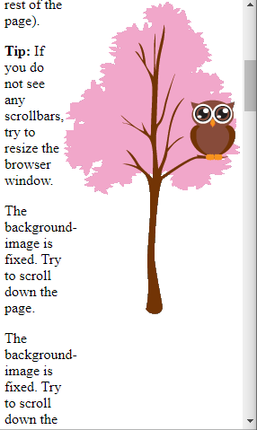

Ejemplo
Especifique que la imagen de fondo debe desplazarse con el resto de la página:
body {
background-image: url("img_tree.png");
background-repeat: no-repeat;
background-position: right top;
background-attachment: scroll;
}
Ejemplo completo:
<!DOCTYPE html>
<html>
<head>
<style>
body {
background-image: url("img_tree.png");
background-repeat: no-repeat;
background-position: right top;
margin-right: 200px;
background-attachment: scroll;
}
</style>
</head>
<body>

<h1>The background-attachment Property</h1>

<p>The background-attachment property specifies whether the background image should scroll or be fixed (will not scroll with the rest of the page).</p>

<p><strong>Tip:</strong> If you do not see any scrollbars, try to resize the browser window.</p>

<p>The background-image scrolls. Try to scroll down the page.</p>
<p>The background-image scrolls. Try to scroll down the page.</p>
<p>The background-image scrolls. Try to scroll down the page.</p>
<p>The background-image scrolls. Try to scroll down the page.</p>
<p>The background-image scrolls. Try to scroll down the page.</p>
<p>The background-image scrolls. Try to scroll down the page.</p>
<p>The background-image scrolls. Try to scroll down the page.</p>
<p>The background-image scrolls. Try to scroll down the page.</p>
<p>The background-image scrolls. Try to scroll down the page.</p>
<p>The background-image scrolls. Try to scroll down the page.</p>
<p>The background-image scrolls. Try to scroll down the page.</p>
<p>The background-image scrolls. Try to scroll down the page.</p>
<p>The background-image scrolls. Try to scroll down the page.</p>
<p>The background-image scrolls. Try to scroll down the page.</p>
<p>The background-image scrolls. Try to scroll down the page.</p>
<p>The background-image scrolls. Try to scroll down the page.</p>
<p>The background-image scrolls. Try to scroll down the page.</p>
<p>The background-image scrolls. Try to scroll down the page.</p>
<p>The background-image scrolls. Try to scroll down the page.</p>
<p>The background-image scrolls. Try to scroll down the page.</p>
<p>The background-image scrolls. Try to scroll down the page.</p>

</body>
</html>

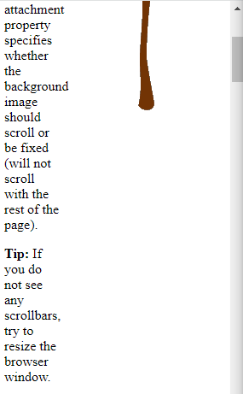

La propiedad background-attachment CSS
Propiedad | Descripcióm
background-attachment | Establece si una imagen de fondo es fija o se mueve con el resto de la página al hacer scroll

